**物理講演会 Report03**

「放射光を用いたX線分光学の最近の進展  
〜物性物理学への応用とデータ駆動科学の導入〜」

水牧仁一朗 先生

In this lecture, 水牧仁一朗 先生 mainly introduce statistics mathematics methods used in the research.

He first introduced the Bayes' theorem, which is a formula for determining conditional probability. Conditional probability is the likelihood of an outcome occurring, based on a previous outcome occurring.

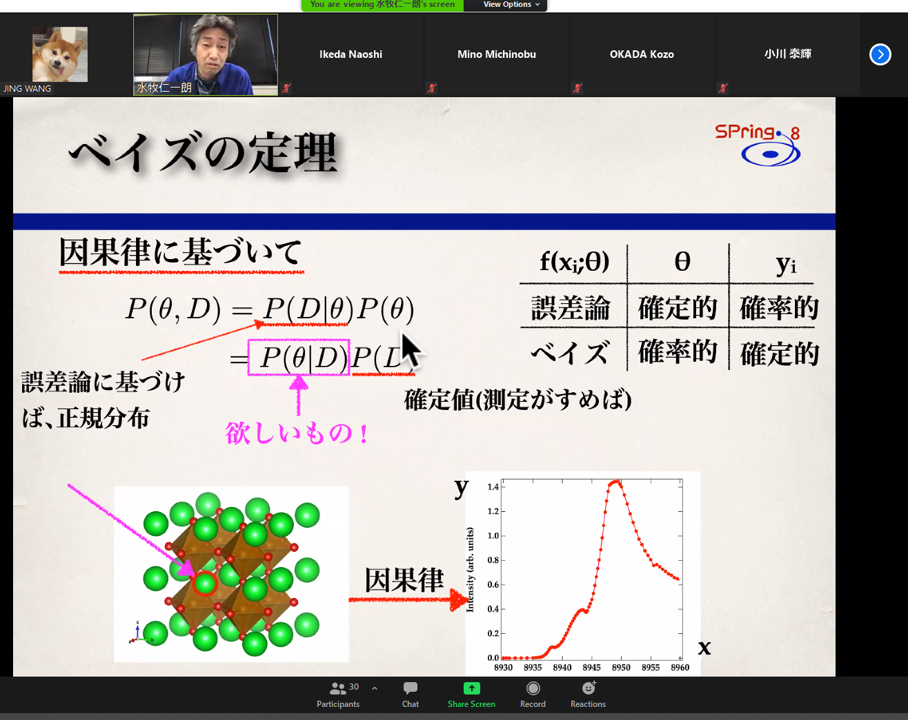

Bayes' theorem provides a way to revise existing predictions or theories (update probabilities) given new or additional evidence.

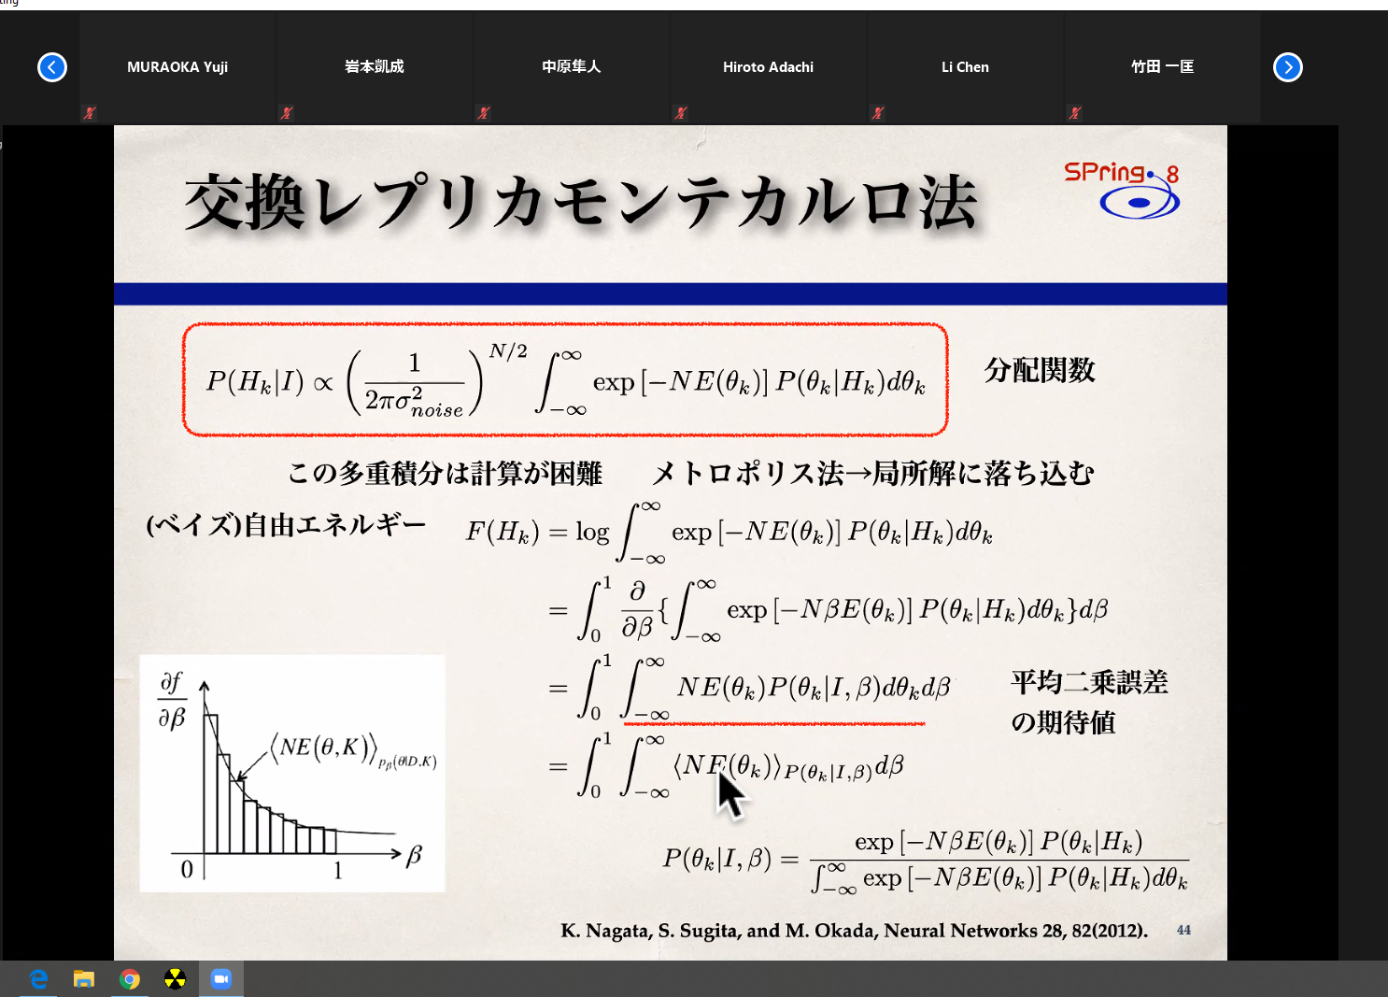

Then, he introduced the Markov chain Monte Carlo (MCMC) methods, which methods comprise a class of algorithms for sampling from a probability distribution. By constructing a Markov chain that has the desired distribution as its equilibrium distribution, one can obtain a sample of the desired distribution by recording states from the chain. The more steps are included, the more closely the distribution of the sample matches the actual desired distribution. Various algorithms exist for constructing chains, including the Metropolis–Hastings algorithm.